**ADA LAB-3**

* **BUBBLE SORT WITH TIME COMPLEXITY**
  + **WRITTEN PROGRAM**
  + **PROGRAM**
  + **OUTPUT**
* **SELECTION SORT WITH TIME COMPLEXITY**
  + **WRITTEN PROGRAM**
  + **PROGRAM**

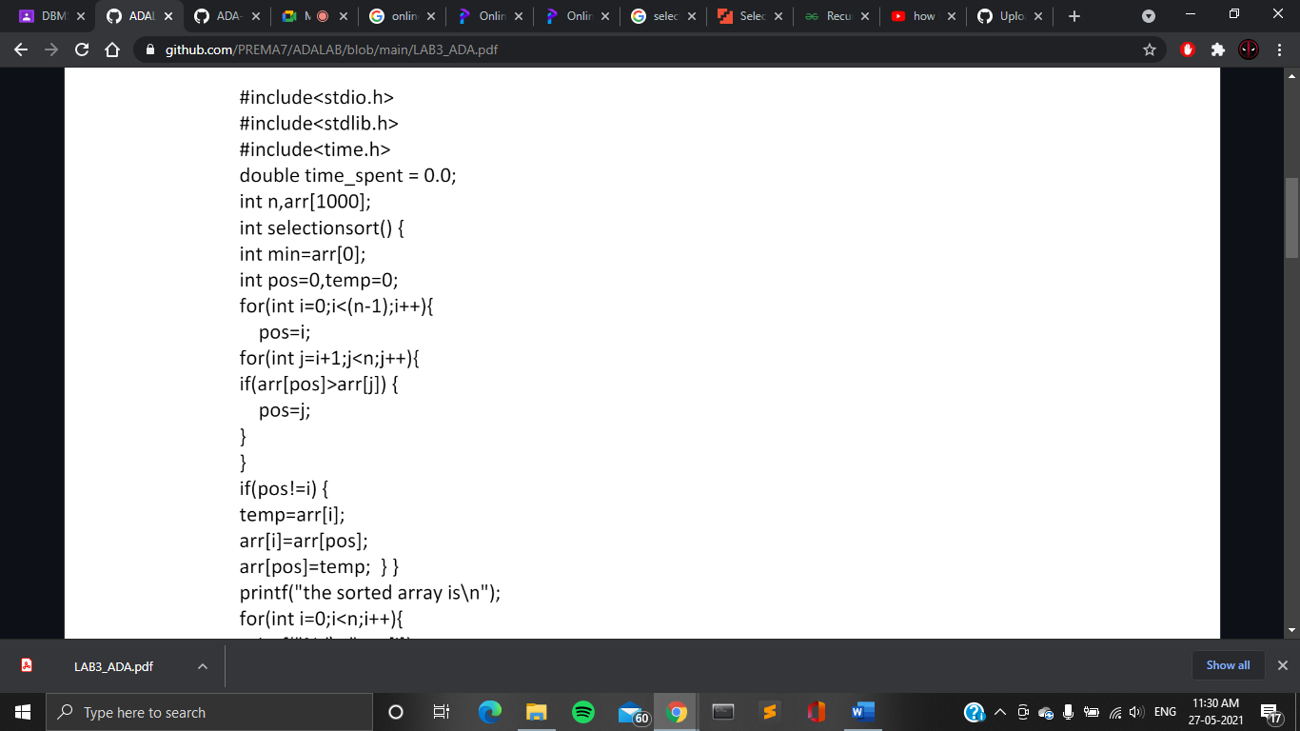

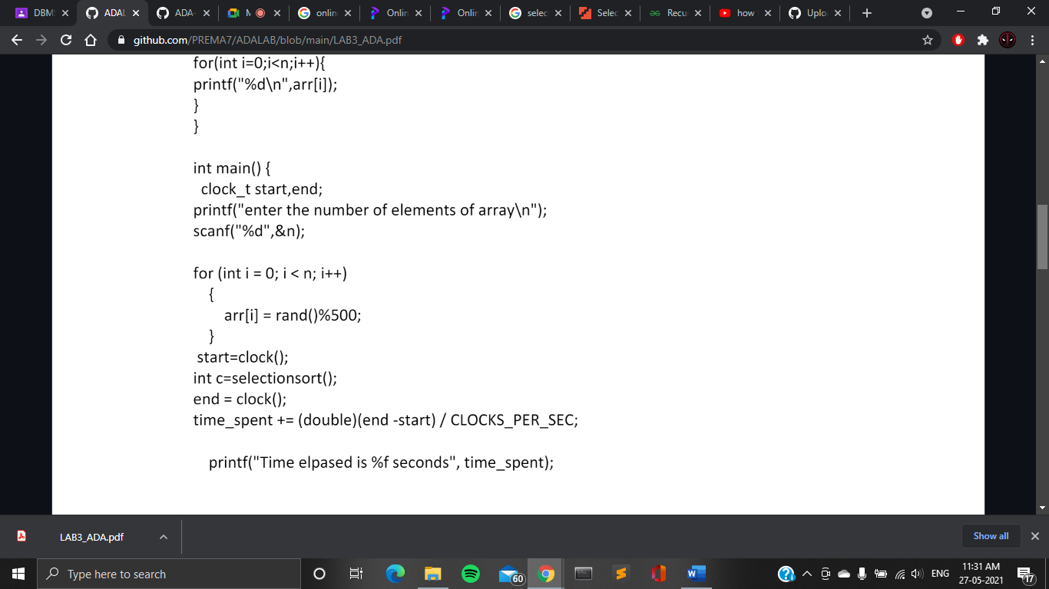

return 0;

}

* + **OUTPUT**

